Extended Abstract
Chemistry (CH)

Title: Development of simple device for determination of ammonium based on light detection and electrochemical detection
CH####
Field: Chemistry
Author(s): Mr.Surasit Kaewtubtim Miss.Kunlaphat Vorarattananurak
School: Princess Sirindhorn's College
Advisor(s): Asst.Prof.Dr. Sumonmarn Chaneam (Department of Chemistry, Faculty of Science, Silpakorn University)

Abstract:
Modern agriculture in Thailand requires the use of fertilizers to provide essential nutrients for plant growth. Whether it is a chemical fertilizer or a biological fertilizer, one of the important elements is nitrogen, which might be in the form of ammonium ions (NH₄⁺). However, the use of ammonium fertilizer is limited because it makes the soil more acidic and may cause an increase in fungal diseases in plants. Analysis of ammonium content in chemical fertilizers and in the soil are therefore important. In this work, we developed a device to detect the amount of ammonium by combining optical and electrochemical detection. For optical detection, a precipitation reaction was employed under basic conditions using ammonium sulfate and sodium tetraphenylborate. A borate buffer was used as the background solution to control the pH. White suspension of ammonium tetraphenylborate occurred and absorbance was measured by a portable colorimeter. The result showed that there was a linearity value at a concentration of 0.1 mM of nitrogen, with an R-Square of 0.99. For electrochemical detection, cyclic voltammetry and differential pulse voltammetry were employed to investigate the current signal of ammonium. A screen-printed electrode was used and connected to a potentiostat to record the signal. The advantages of using two measurement techniques simultaneously are that it may help extend the range of analysis or provide additional data to confirm the accuracy of the analysis. Furthermore, the use of electrochemical techniques helps minimize interference from the color of the sample.

Keywords: light detection, electrochemical detection, ammonium, precipitation reaction, fertilizer

Introduction
Modern agriculture requires the use of fertilizers to provide essential nutrients for plant growth. We are interested in the element nitrogen in the form of ammonium ions. Nitrogen is the main component of protein and helps nourish the leaves. However, the use of ammonium fertilizer has its limitations. It is therefore important to analyze the amount of ammonium in chemical fertilizers and soil. Standard analysis must be carried out in a standardized laboratory. This is a complex and difficult process that causes delays.
In this work, the researcher therefore aimed to develop a new test kit for ammonium content. To ensure convenient and efficiency, if more than one technique can be analyzed on the same measuring device, it will enhance the reliability of the analysis results.

Methodology
1. Solution preparation
Standard ammonium sulfate of 70 mmol N/L 50.00 mL was prepared by weighing 0.24 g of ammonium sulfate with analytical balance 4 digits into a beaker, next dissolve with DI water, and then adjust the volume to 50.00 mL with a 50.00 mL volumetric flask. Borate buffer 10 mmol/L 100.00 mL, used as supporting electrolyte and background solution to control pH, was prepared by weighing 0.38 grams of sodium tetraborate into a beaker, dissolve with DI water, and finally adjust the volume to 100.00 mL. The pH was adjusted to 9 by dropping 6 mol/L NaOH HCl acid, respectively. Sodium tetraphenylborate, employed as a precipitating agent, was prepared by weighing 1 grams of sodium tetraphenylborate and dissolve with DI water and adjust the volume to 50.00 mL.

Results, Discussion and Conclusion
1. Optimization of some parameters affected to detection
A background solution that used to controlled pH, which were with KOH, NaOH and borate buffer was investigated and the results were shown in Fig. 1.
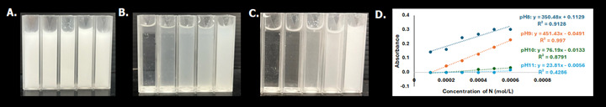
Fig. 1 Standard ammonium solution at various concentrations in a background solution of KOH (A), NaOH (B) and borate buffer (C) Cyclic voltammogram of ammonium in NaOH and ammonium in borate buffer (D).
When using KOH as background solution, it was found that the resulting solution was predominantly white color in all tubes, due to the reaction between K⁺ and tetraphenylborate forming a precipitate of potassium tetraphenylborate, resulting in excessively high absorbance values measured (Fig. 1A), leading to inaccurate analysis results. Therefore, NaOH and borate buffer could be used for precipitation reaction of ammonium tetraphenylborate. However, borate buffer showed better sensitivity than NaOH (Fig. 1B and 1C). Then we test the reaction of the solution with borate buffer at different pH in colorimetric detection. We collect data to plot a graph showing the relationship between concentration and absorbance, measured by portable colorimeter, at various pH as shown in Fig. 1D. Here, pH 9 showed the best sensitivity with linear equation: y = 451.43x – 0.0491 and R-square = 0.9972. Hence, borate buffer pH 9 was selected as the background solution for light detection and was selected as the supporting electrolyte for electrochemical detection as well.
2. Electrochemical detection
Firstly, the electrochemical behavior of ammonium ion on the screen-printed carbon electrode was investigated by cyclic voltammetry (CV) as showed in Fig. 2A. Oxidation peak of ammonium was presented at 0.9-1.0 V vs Ag/AgCl and reduction peak was not appeared. In order to improve the sensitivity of ammonium detection, differential pulse voltammetry (DPV) was used instead of CV. DPV voltammogram showed in Fig. 2B. Notice that, peak current at applied voltage of 0.9 was picked up and used to construct the calibration curve for quantitative analysis.
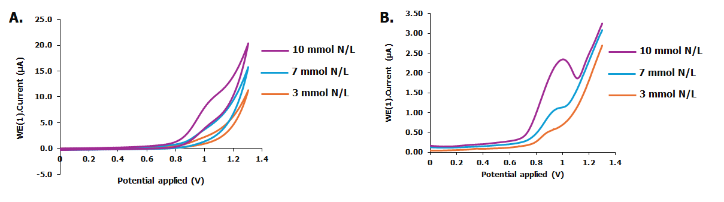
Fig. 2 The binding energy (Eb) of Cu-, Pt-, and Pd-B₂N₄-graphene surface. Cyclic voltammogram (A) and differential pulse voltammogram (B) of ammonium ion at various concentration on screen-printed carbon electrode in borate buffer pH 9.

Acknowledgements
This project was supported by Science Classroom in University Affiliated School (SCiUS). The funding of SCiUS is provided by Ministry of Higher Education, Science, Research and Innovation. Also, thanks to Department of Chemistry, Faculty of Science, Silpakorn University for supporting the chemical laboratories, tools, and equipment throughout this project. This extended abstract is not for citation.

Declaration
This work was created without any contribution from a generative AI. The authors also affirm that this work has not been previously presented or submitted to any other competition.

References
- Guo C, Zhang T, Deng X, Liang X, Guo W, Lu X, et al. Electrochemical CO₂ Reduction to C₁ Products on Single Nickel/Cobalt/Iron-Doped Graphitic Carbon Nitride: A DFT Study. ChemSusChem. 2019;12(23):5126-32.
- Huang M, Deng B, Zhao X, Zhang Z, Li F, Li K, et al. Template-Sacrificing Synthesis of Well-Defined Asymmetrically Coordinated Single-Atom Catalysts for Highly Efficient CO₂ Electrocatalytic Reduction. ACS Nano. 2022;16(2):2110-9.
- Tripathi A, Thapa R. Optimizing CO₂RR selectivity on single atom catalysts using graphical construction and identification of energy descriptor. Carbon. 2023;208:330-7.
- Maulana AL, Saputro AG, Prasetyo Y, Mahyuddin MH, Iqbal M, Yudistira HT, et al. Two-Electron Electrochemical Reduction of CO₂ on B-Doped Ni–N–C Catalysts: A First-Principles Study. The Journal of Physical Chemistry C. 2021;125(35):19247-58.
- Gu X, Jiao Y, Wei B, Xu T, Zhai P, Wei Y, et al. Boron bridged NiN₄B₂Cx single-atom catalyst for superior electrochemical CO₂ reduction. Materials Today. 2022;54:63-71.

